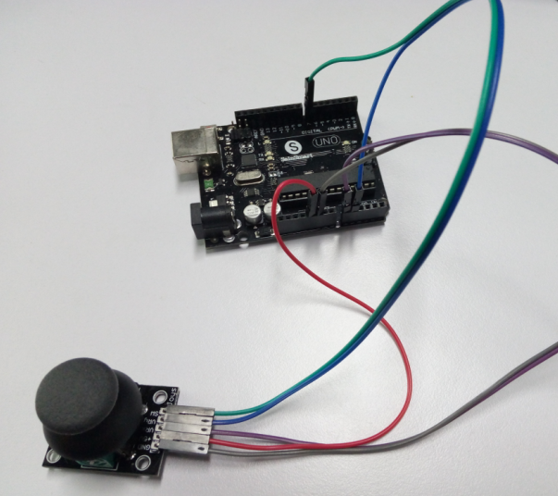

First, the product description

The company produces PS2 game joystick axis sensor module consists of using original quality

metal PS2 joystick potentiometer system

For, with (X, Y) 2-axis analog output, (Z) 1 digital output channel button. With Arduino sensor

expansion board can be made

For remote control and other interactive work. In addition the product in order to allow customers to more easily fit arduino expansion boards and other standard interfaces

Mouth, in the design of the X, Y, Z-axis circuit leads individually, you can use three dedicated

lines really pin ARDUINO Plug into the expansion board for use. It is convenient.

Second, product characteristics

It is like a game console joystick, you can control the joystick module input x, y, z of PS2 joystick game controller module Joystick Values, and to achieve a particular value in a function, it can be considered a combination of buttons and a potentiometer. DataType of x, y dimension for the analog input signal is a digital input signal z dimension, therefore,x and y connected to the analog port Pin sensor end, and z port is connected to the digital port.

Third, the use:

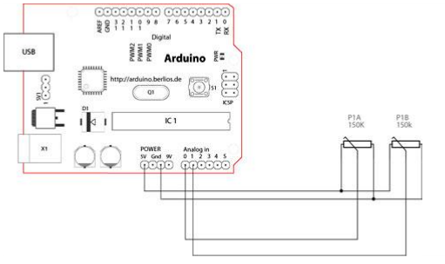

On how to use, we first look at how it works now, so we know it is there in the end

How, which we find it helpful to use, there is a functional diagram below, we take a look

Now we should clear it, in fact, it is a potentiometer Well, x, y dimension of the data output is

Analog Port readout voltage value, is not a little surprised. Of course, this is not shown above, z-

dimensional data output, in fact, it is more

Simple, we know that z-dimensional output only 0 and 1, then it can be achieved through a button bar. Now on we should Surface of saying, it is a potentiometer and button combination (To be honest, if you do not understand it just to see that Sentence is a bit foggy it? ).

After reading the chart I believe we all know how to use it right Arduino, x, y dimension we received two analog ports

Read their values, and z dimensions we are to the digital port, so that the line, plus the power and ground, so fine. . . .

Fourth, the module test

Let's look at this test what things we have, in fact, not much. . . .

Arduino controller × 1

USB data cable × 1

Game sensor module × 1

Here x I connected an analog port 0, y even an analog port 1, z I connect to the digital port 7, the

relevant port No. You can look at the individual situation, but properties can not be wrong.

Code is as follows:

int sensorPin = 5;

int value = 0;

void setup() {

pinMode(3, OUTPUT);

Serial.begin(9600);

}

void loop() {

value = analogRead(0);

Serial.print("X:");

Serial.print(value, DEC);

value = analogRead(1);

Serial.print(" | Y:");

Serial.print(value, DEC);

value = digitalRead(7);

Serial.print(" | Z: ");

Serial.println(value, DEC);

delay(100);

}

